WHU−Otto Beisheim School of Management

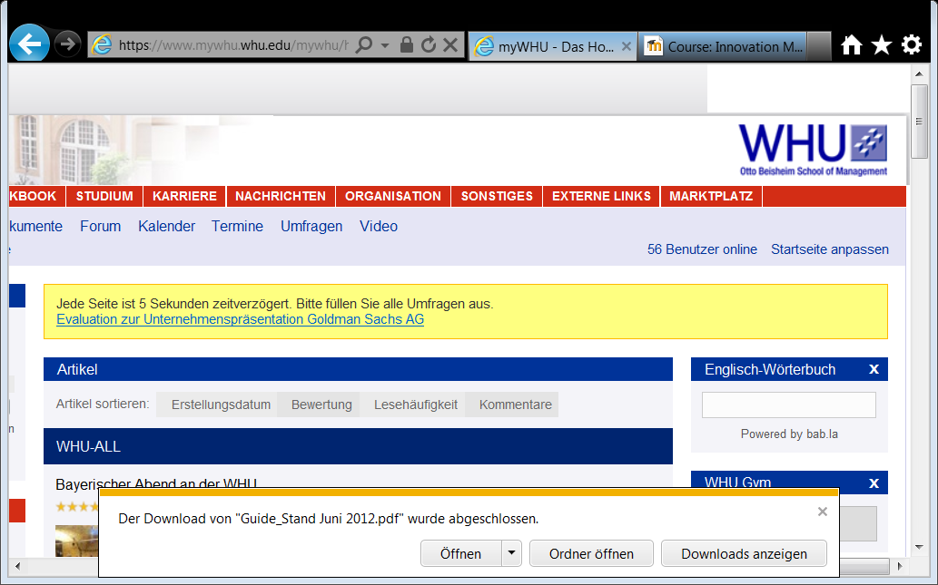

Assignment II

Technology Modelling

Software Development for Start-Up Entrepreneurs

[SOFTLANG Team, Universität Koblenz-Landau](http://softlang.wikidot.com/)

Submission Date: April 2th, 2014

Submitted to: Prof. Dr. Ralf Lämmel

By

Daniel Deutsch

Schulstraße 10, 56179 Vallendar

Born May 11th, 1991 in Bad Ems

Justus Hammer

Heerstraße 60, 56179 Vallendar

Born May 1st, 1992 in Duisburg

Christina Heise

Burgplatz 1b, 56179 Vallendar

Born December 25th, 1989 in Hamburg

In this assignment we will have a look into data exchange APIs (Application Programming Interfaces) and pay special attention different programming languages for which the APIs are specified for.

We have come to this topic, as it seems to be a recent issue with developers which languages are most efficient for the use of these APIs.

The most common language that is used for this, as we found out in our research, seems to be XML (Extensible Markup Language). But there is an ongoing discussion, if JSON (Java Script Object Notation) is better and quicker and so favorable for what uses. For this discussion we looked into the following articles:

<http://appbus.wordpress.com/2013/12/08/json-vs-sql/>

<http://www.mashery.com/blog/api-data-exchange-xml-vs-json>

Apart form looking into the different entity types and their relationships, we want to give a short introduction to data exchange APIs and their function. Further, compare XML and JSON and their advantages and disadvantages. Moreover, we give a short overview over an example API named Jetpack by WorldPress and the possible data endpoints of this API.

First we start with the different entity types and related entities that are involved within the use of an API for the data exchange process. Data exchange APIs in general are used, when the applications that want to exchange the data aren’t in the same network but have to exchange the data over the internet. This could be also done by single requests for simple one time uses. But for a stady process of data exchange an API is really helpful to interact with an application in a programming language. APIs are typically written to support mostly one or several programming languages in which we want to interact with other applications databases. The most used one is XML, as this language of data format, which is also called a markup language, has the advantages that it defines a set of rules for encoding documents in a format that is easily readable for machines and humans. The specifications of XML are defined by the W3C (**World Wide Web Consortium**) which is the main international [standards organization](http://en.wikipedia.org/wiki/Standards_organization) for the [World Wide Web](http://en.wikipedia.org/wiki/World_Wide_Web).

Following we want to list the earlier used entity types and entities:

1. Specifications as done by the W3C for XML or the Java language specification of JSON
2. Languages: The markup/query languages XLM and JSON and SQL in which most databases are written in.
3. The technology are the APIs which help the data exchange process, but in general were originally build to make it easier for third party developers to create integrating functions.
4. Organizations like W3C that specify languages like XML
5. Roles: Developers that make use of other applications data through the exchange of data over the web
6. People: a developer like [Douglas Crockford](http://en.wikipedia.org/wiki/Douglas_Crockford) who first specified JSON.
7. Requests that are done by the API to the data source of another application in the language it is programmed for.
8. Responses that are returned for example in the language XML or JSON.
9. Artifacts: for example the data files those are exchanged through the API.
10. System: In this case if these needed APIs are work as on offered web service

Next we want to list the detected relationship typs we came acrossdwhile researching on the topic.

1. part of relationship: e.g. APIs are part of web application services
2. uses relationship: e.g applications use APIs for the smooth data exchange, APIs use different markup languages like XML or JSON
3. is a specialization of another concept: Data exchange APIs are a specialization of the general APIs and their other/ original uses
4. supports: Markup languages like JSON support different programming languages, sometimes helped by specific encoders as there can be found many like on this website for JSON <http://www.json.org>, for example this one for Phyton: <https://pypi.python.org/pypi/simplejson/>
5. transformed: by this APIs the data of other applications is transformed from typical SQL to the type of XML or JSON
6. yieds: the request by the API yieds XML or JSON file response.
7. has developed: [Douglas Crockford](http://en.wikipedia.org/wiki/Douglas_Crockford) has developed/ specified JSON
8. knows of: developers know of the usage of APIs and and different languages

As an example of such an API for Blogs we looked into this JSON API by WorldPress for bloggers: <http://jetpack.me/support/json-api/>

Interesting for us was what types of data are the actual endpoints, so the information that is exchange by this process in the end. Special in this API it seems to be for us that the relevant data is not just about users, but their data of behavior like comments or post that plays an important role in this API. Also this API shows who follows whom or what was freshly released.

To conclude, we think that these APIs are an important part in the world of big data and its efficient use through web services or other applications.

Sources:

<http://appbus.wordpress.com/2013/12/08/json-vs-sql/>

<http://www.mashery.com/blog/api-data-exchange-xml-vs-json>

<http://de.wikipedia.org/wiki/JavaScript_Object_Notation>

<http://en.wikipedia.org/wiki/XML>

<http://www.json.org/xml.html>

<http://en.wikipedia.org/wiki/W3C>

<http://www.openthesaurus.de/about/api>

<http://www.idealware.org/articles/data_exchange_alpha_soup.php>

<http://sql-plsql-de.blogspot.de/2012/09/json-generieren-in-der-datenbank-mit.html>

<http://jetpack.me/support/json-api/>

<http://developer.wordpress.com/docs/api/>

<https://pypi.python.org/pypi/simplejson/>